My experience with solar power in Washington state
(lessons learned)
Rev3 Sept 16 2010
Rodger Herbst

There are several philosophies on the use of photovoltaic systems. One philosophy is to spend $30,000 on a full up system installed by professionals. Today that will get you twenty or so solar panels (about 2000 watts) with a control system that includes a special synchronous inverter to “tie in” to the local power company’s electrical grid. That just means that the power from your inverter, which converts the DC produced by the solar panels to AC, will be automatically in phase with the AC provided by the power company. This has the advantage of not requiring really any work or knowledge on your part, nor batteries, but is very expensive, keeps you uninformed about what is going on, and allows for no “on site” power supply. You have the luxury of being able to use your existing wall socket power outlets, but also will be in the position of having no power during power outages. If your installers are reputable, you will be fine.

Another philosophy is to do it yourself, start with a small system, include batteries to allow for some on site power storage, learn how the whole system works, and gradually “grow” it to the point where it may eventually be “tied in”. Make sure the work meets local electrical requirements; as many as three separate inspections will be required to “tie in” to the local power grid.

I am an advocate of growing a small do it yourself system. I bought my first solar panels in 1993. They were a set of four (quad) Carrizo nominal four volt framed ARCO M52 laminates, each 1 ft by 4 ft by 2 inches, taken from a large power grid that for some reason had been dismantled. The nominal voltage for the set of four wired in series was stated to be four times four, or sixteen volts, enough to charge a twelve volt battery. The nominal power output was 25 watts per panel, or about 100 watts, for about $200. That’s 2$/Watt.

I was living in Woodinville, an area with lots of trees, and the system was not even tested until much later. When tested, in July 2006, the measured open loop voltage was 30 VDC. Open loop current was 5.6 amps. (I did not have the resistors needed to estimate power output)

In 2006, the average cost of new solar panels was about $5/Watt, or $500 for one hundred watt panel. Since then the cost of solar panels has fallen to as low as $2/watt, but this is usually for purchase of 10 or more panels. SolarBlvd.com is one of the few companies I have found that has consistently low prices, even for purchase of only one panel.

In the fall of 2008 I set up the quad system on a rooftop of my small sustainability home in Snohomish Washington, an area having good sun exposure. The four panels were mounted in a four by six foot aluminum frame specifically to hold them. I did not want to put holes in the roof, so I anchored the frame with large clamps.

I knew that for my simple system with on site energy storage I would need some kind of DC storage battery, an inverter to convert the stored energy in the battery to AC current for powering household electronic gadgets, and probably a solar controller. The idea is that you have the energy source, which is the battery, and the solar panels to charge the battery. The battery and panels are connected to the “controller”, which then provides an output of direct current which goes to the inverter. You plug your AC light bulb into the inverter. When using batteries in a PV system, with no connection to the local power grid, it is helpful to think of the entire system as a glorified battery charger, since you obtain your power directly from the batteries, not the solar panels.

To start off, I purchased a single Optima Yellow Top “deep cycle” 12 volt sealed battery with 38 AmpHour capacity, primarily because it had a long storage life. That was probably a mistake, but it did give me my first off grid lighting.

I had read that a “true sine wave” inverter is important, especially for use with electronic equipment such as computers. The alternative is the modified sine wave inverter, in which the sine wave is generated by a series of steps. Needless to say, the true sine wave inverter is much more expensive. Power supplies for electronic gadgets, like laptops or PCs, convert household AC current back to DC power. In the early years, power supplies often would have trouble converting step sine wave signals to DC, so your PC might buzz. Although some power supplies still have that problem, many now have filters which will smooth their output, giving continuous DC output even with a step sine input. So I decided to go with a cheap $25 200 watt modified sine wave inverter.

The solar controller prevents battery overcharge by the solar panels. The Morningstar Sunsaver uses “pulse width modulation” technology to ramp to the optimal battery charging. In this case the overcharge is not off-loaded, it is lost. The Sunsaver 10 and 20 amp versions provide a green LED to indicate the solar panels are putting out voltage, and a red LED to indicate that the load has been disconnected from the batteries due to low battery voltage. When the sun goes down, the green LED goes off. The controller also prevents current from back-flowing into the solar panels when they are not generating power.



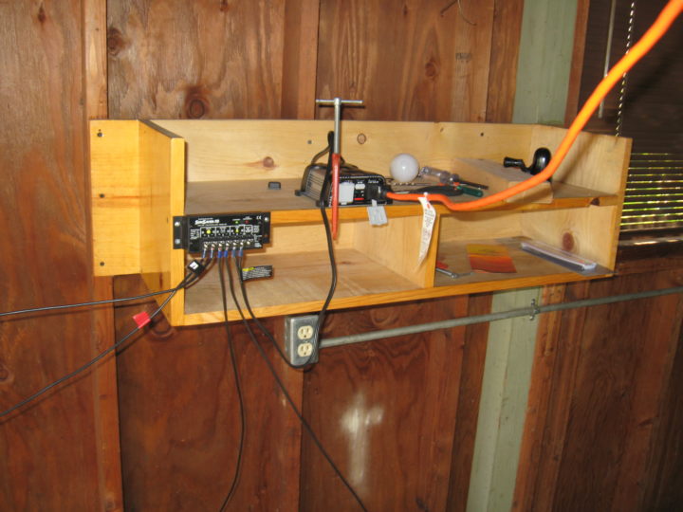

By summer of 2009 I decided to upgrade the system.

I purchased and installed four six volt Trojan T-605LPT type batteries, rated at 210 AH per battery at the 20 hour rate. (I was lead to believe these were the same as the Trojan T-105 batteries, rated at 225 AH per battery at the 20 hour rate. Be cautious in dealing with vendors); a Black and Deker 400 watt modified sine wave inverter, and one nominal120 Watt Solar Cynergy 12 volt polycrystalline solar panel from BolarBlvd.com, for $350. (41.x31.4x1.4 inches; 20 lbs)

I also purchased another 1250 Watt modified sine wave inverter, for $129, for future expansion.

The four 6 volt 210 AH batteries were wired in a combination of series and parallel as shown below to give an output of twelve volts and with a 420 amp-hour capacity:
image from: http://www.trojanbattery.com.cn/images/IncreasePower_clip_image006.jpg

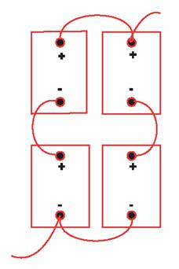

By autumn of 2009 I had a nominal 220 watt capacity system. Early the following spring however, my quad system stopped working, and I had no idea why. The four panels were wired in series on the roof. I had no choice but to remove them and track down where the problem was. When I remounted the four panels, I rewired them so that the series connections were made inside the garage the panels were mounted on. I did the same thing for the 120 watt Solar Cynergy. I separated all connections with switches so that I could test each panel for voltage and amperage from the comfort of the garage.

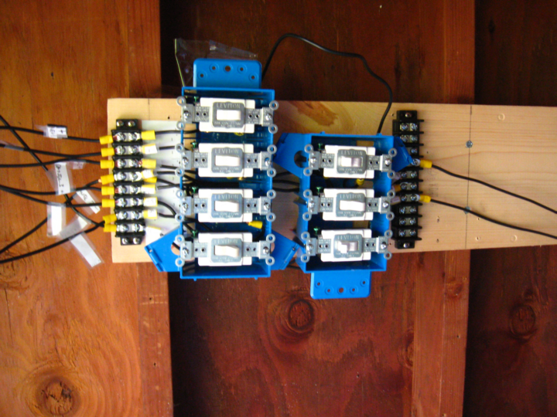

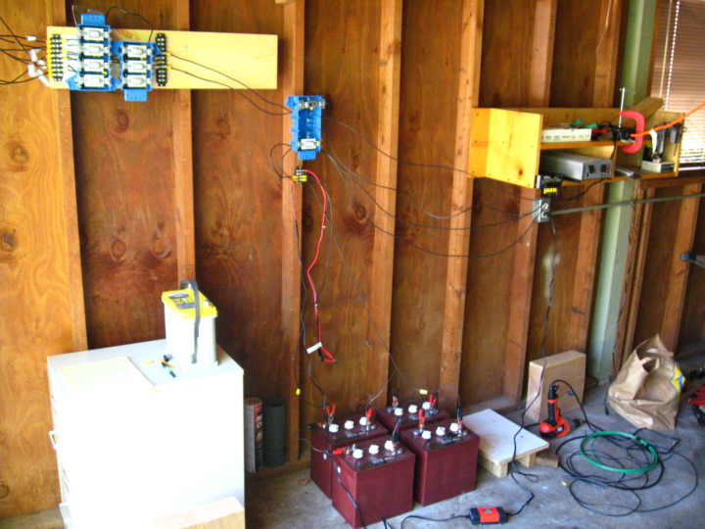

Almost as soon as I had gotten my test panel set up, I noticed that the voltage of the Solar Cynergy 12 volt polycrystalline solar panel was failing. The actual operating voltage of a nominal twelve volt solar panel (or set of solar panels) is typically about 24-26 volts. The voltage I was reading from the test panel was barely eleven volts, which meant that the panel was not able to charge the twelve volt battery system. It was useless. I also noticed that the solar controller had disconnected the load, meaning that the Trojan battery voltage was seriously low. But why was this? The Morningstar controller had shown a consistent green LED. This means that the green LED was lit even though the voltage from the Solar Cynergy was too low to charge the battery pack.

I next purchased a Black & Decker 1-2 amp battery charger. This charger shows a yellow LED when the battery pack is anything but fully charged, and a green LED when the battery pack is fully charged. The charger is wired directly to the batteries at all times. When the batteries are being charged by the solar panels, no current is being drawn from the charger; ie from your household power supply. When the batteries are not being charged by the solar panels, the trickle charger kicks in to keep the batteries charged.

I contacted SolarBlvd.com abut the failed panel in May 2010. They asked that I ship it back, and they would have it fixed or send me a new one. Via UPS, I had the panel repackaged and sent back to SolarBlvd on May 24, 2010.

On June 28 2010, I purchased a Sunwize SW100C 100 Watt 12 volt monocrystaline panel from SolarBlvd.com for $226 (57x23 inches, 23 lbs), and received it by mid July. This panel is internally wired to allow production of energy even if part of the pane is shaded. (Normally if any part of the panel is shaded, a short circuit prevents any power from flowing.)

On about July 21 2010, after a number of unsuccessful inquiries, SolarBlvd.com finally responded that they had not heard back from Solar Cynergy, had no idea what the problem was, and would send me another working Solar Cynergy 12 volt polycrystalline panel. I noted that the price of the Solar Cynergy 120 had dropped from $350 to $282 (normally $600) between July 2009 and July 2010.

Still, no solar panel from SolarBlvd.com. On August 21 2010, I called again. The company representative said they had finally gotten a shipment of Solar Cynergy panels in and would send one right away. On September 13 I called again, talked with a different sales person, suggested I speak with a manager, and again was told they would send one out right away. I got a call back from the operations manager. I noted that Solar Blvd was already being tracked by the Better Business Bureau of Southern California, http://los-angeles.bbb.org/Business-Report/Solar-blvdcom-100094344 and indicated that if I did not see a shipping notice within the next week, I would file an additional complaint. Two hours later I got a call back providing me with a shipping number.

Measuring the power output of the solar panels

A good set of instructions on how to determine the power output of your solar panels is provided at Reuk [http://www.reuk.co.uk/Measuring-the-Power-of-A-Solar-Panel.htm]. However, the diagram showing how the panels, multimeter, and resistances are connected for measuring voltage and current is confusing:

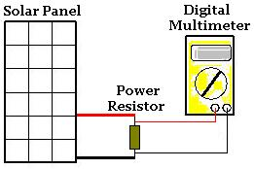

This diagram correctly shows how to measure the voltage drop across the resistances, as well as the open loop voltage if the resistor is removed, and the closed loop voltage if the resistor is replaced by a conducting wire. However, to measure the current through the resistor, the following is the correct wiring.

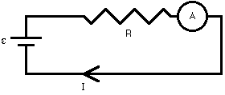

From http://buphy.bu.edu/~duffy/PY106/Ammeter.GIF

It is assumed that for an open circuit, no current flows, so if you connect your multimeter/ammeter to the panels, you will really be measuring the closed circuit or short circuit value of current flow.

In early September 2010 I ordered the four power resistors suggested by Reuk; 100, 50, 25, and 5 Ohms, rated at 100 watts of power, at $10 each.

After burning out several of these resistors, I discovered that they need to be mounted in a heat sink to dissipate the heat they generate. I further discovered that to really get the shape of the Amps vs Volts curve, you also need 2 and 1 Ohm resistors.

Finally, on September 14, at 4:30 pm, I got enough steady sunshine and had enough resistors to take some measurements. I was determined to estimate power.

The Reuk article states that all plots of voltage vs current from solar panels has this shape:

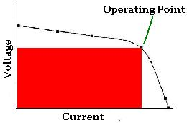

Using the “Graph” plot program, downloaded from http://www.padowan.dk, I plotted the measured data points for the resistors I had, which show nice slopes for both the quad and Sunwize panels from the open loop voltage and closed loop current points. Because I burned out the mid range resistors, I also used this graph program to construct straight lines extending the data points, and estimated a mid point in the bend of the estimated curve smoothly connecting these two lines. Since P=IV, or Watts = Current X Voltage, the estimated power output of the quad was 37 watts, and of the Sunwize 33 Watts. (Remember this is 5 pm September 14)

I still need to collect the entire set of resistors and mount them in heat sinks to get ready to measure peak solar power in the northern hemisphere at my latitude, which is roughly mid day, June 21. As you can see, learning the nuts and bolts of solar power from scratch is an iterative process.

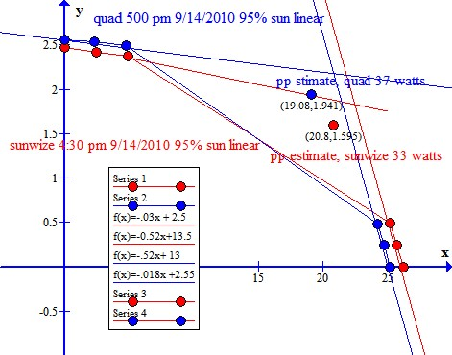

Peak power estimate for ARCO Quad and Sunwize unit Sept 14 2010 4:30-5:00 pm
Using http://www.padowan.dk (free) graph program

Eventually the tables for these values, as well as further plots will be found here:
my_solar_attach1.doc or my_solar_attach1.htm

Light flickering anomaly
I had been using solar power to charge the Trojan batteries for most of my house lighting for the last year or so. This is typically several compact florescent light bulbs, with a total power consumption of about 50 watts. However, about 6 PM on August 27 2010, my 25 watt Ott light on (in lamp A). It starts flickering. I see that the B&D charger is flickering from green to yellow; ie from charged to uncharged. A few minutes later, the light goes off.

The B&D inverter is in yellow mode, which means an input or output problem. I plug in a small light to inverter; still yellow. Then I turn off the inverter.
I shut off solar to the controller, then shut off battery to controller; then hear clicking noise; it is the B&D charger cycling rapidly between yellow and green (charging and charged). Trojan battery pack: 6.75 volts open loop. I turn off the charger. 10 minutes later I check voltage: 13.3 I turn on charger; no cycling; constant yellow (charging). Connect battery pack and solar back to controller. Turn on inverter it is good. (green)
I turn on 25 watt bulb again; it begins flickering immediately. I try several hours later, and it again flickers.
After switching light bulbs and lamps, it appears the flicker is caused by the PV system.
It is possible that the cause of the flicker and shutdown is the inverter. The four hundred Watt Black and Decker inverter solved the flicker problem in 2009, when it replaced the first inverter I bought, a 200 watt Power Bright. To test this, I hooked up the Aims 1250 Watt inverter, which also estimates input closed loop voltage and output wattage in real time [via 9 step bar graphs, from 10.5 to 15 volts, and from 125 to 1250 Watts respectively]. The light flicker stops. Conclusion: Inverters seem to be prone to this problem.

Battery/power monitoring
One would normally try to operate the solar battery pack in such a way as to optimize performance. That means to get the most output without causing excessive wear on the battery pack. Normally this means using deep cycle batteries, which are made for constant charging and discharging. The weight of deep cycle batteries is due to the large amount of lead, which minimizes the effect of sulfidation, a main cause of battery deterioration..

Battery performance depends on a number of factors. The Peukert effect is one of the most important, and is directly related to the internal resistance of the battery. The higher the internal resistance, the higher the losses while charging and discharging, especially at higher currents. This means that the faster a battery is discharged, the lower the AH capacity. AH capacity is given, typically at the hour and 20 hour discharge rates. Some manufacturers and vendors have chosen to rate their batteries at the 100 hour rate - which makes them look a lot better than they really are. [http://www.windsun.com/Batteries/Battery_FAQ.htm ]

However, even if deep cycle batteries with a lot of amp hours are used, the number of cycles the battery pack will provide depends on the depth of discharge.

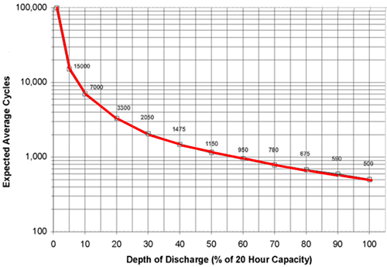
From: http://www.mpoweruk.com/life.htm

The idea is that you want to minimize the depth of discharge to prolong productive battery life. The logarithmic plot above shows that if your 20 hour battery capacity is 420 amp hours, then discharging to 20%, or 84 amp hours, will allow 3300 cycles, while discharging to 50%, or 210 amp hours, will allow 1150 cycles.

There are theoretical ways to estimate the effect of use of the battery pack on state of charge. Using the calculator at http://www.gizmology.net/batteries.htm, the theoretical 420 AH system, assuming a Peukert number of 1.1, the actual capacity is 390 AH. Having a load of 2.1 amps, the 25 watt bulb could be powered for 37 hours to discharge the battery by 20 %, and 148 hours to discharge the batteries by 80 %

The Trojan battery state of charge vs open loop voltage: http://www.trojanbattery.com/BatteryMaintenance/Testing.aspx shows some important numbers:

SOC 12 volt
% Open loop
Voltage

100 12.73
80 12.5
60 12.24
50 12.1
40 11.96

However, for accurate open loop voltage testing, the batteries must be disconnected from all other hardware and be idle for 6 hours. Not very useful information for on the fly battery monitoring.

The Aims 1250 Watt inverter also estimates closed loop input voltage and output wattage in real time. However, closed and open loop voltages are not the same. The difference is that the closed loop configuration is based on Kirchoff’s law, which states that the sum of the voltage drops in the system; ie across the batteries, controller, solar panels, and inverter must be zero. In short, it is difficult, if not impossible, to pull the open loop voltage from the closed loop value.

The best solution seems to be an amp hour meter of some sort. http://www.solar-catalog.com/sys_mon.html For example, if your battery pack is rated at 420 amp hours, and the internal resistance (Peukert number) is 1.1, than the actual charge is 390 amp hours. A 20% depth of discharge would therefore be 78 amp hours. When the amp hour meter reads 78 amp hours, it is time to recharge the battery pack. Most amp hour meters use a shunt-monitor combination.
http://www.genverters.com/power-systems/battery-monitor-shunt/

The Trimetric 2020 monitor from Bogart Engineering measures amp hours per battery discharge cycle, for about $150. The Trimetric 2025 monitor does all that and more, including keeping track of amp hours of total battery life, for about $220.

The Pentametric, also from Bogart Engineering, comes in three units; an input module, a display module, and a computer interface. The input unit provides for multiple shunt inputs, so you can record as well as see, for example, not only how much power is coming out of the battery system, but also how much is going in, via your solar panels. The Pentametic also provides for temperature sensing, data logging, and PC interface by USB. http://www.aeesolar.com/catalog/products/H_ASW_MM_DCAH_PB.htm

http://store.solar-electric.com/pe3chbamosy.html, http://solar.altestore.com/energy/Pentametric, and http://stores.mavericksolar.com all have the entire system for about $500, but you will probably also have to buy a USB serial adaptor, available online for $15-20.

To be continued

