Chaos notes:
Steven Strogatz “Chaos” DVD teaching company

Lecture 1: The Chaos Revolution
For a long time, science avoided chaotic systems. In the 1980s, a few mavericks from every scientific disapline said we need to try to understand chaotic systems. They found that chaos in different physical systems looked the same; for example, patterns that geologists found in the frequency of earth quakes were similar to the patterns physicians found in heart rate variability; and these patterns were also similar to the patterns found in internet traffic. The patterns look similar regardless of the scale at which the patterns are viewed. (like fractals) chaotic systems are deterministic but not predictable. Chaos theory shifts the focus from the laws of physics to their consequences. It uses a computer in a radical new way, to see the consequences of the laws. ; holistic; ie includes the effects of the parts to the whole scientific holism; Interdisciplinary; simple systems can behave chaotically. Complex systems may exhibit simple patterns. “Fractals are the footprints of chaos”

Finished lecture 1

Lecture 2: The clockwork universe
Finished lecture 2

Lecture 3: From clockwork to chaos
Newton and determinism dominated not only science, but philosophy and politics for hundreds of years.
By mid 20th century, three tiny cracks began to appear in our deterministic perception of the universe: einsteins theory of relativity, quantum mechanics , and Chaos.
Newton’s solution of the simple two body problem (say sun and earth) was based on converting a non-linear differential equation, very difficult to solve, to a linear, simple to solve differential equation: the solution was that for a simple harmonic oscillator. Science and engineering routinely make this conversion from non-linear to linear, by assuming small perturbations, etc. no one could find solution to three body problem; so came up with a way to approximate a solution to the problem using perturbation theory. Was successful; Predicted existence of planet Neptune. Vindication of perturbation theory. Still, an exact solution was again attempted, but failed. The reason it failed was not because no one was smart enough to solve it, but because there was a deep mathematical reason why the problem was unsolvable: a computerized simulation of the three body problem with one of the bodies being a speck showed a chaotic trajectory; one that could not be described by an equation.

Lecture 4: Chaos found and lost again
Poincare found that the three body problem led to chaos. Poincare’s method used visualization and is central to chaos theorists today. He drew pictures of the objects traveling thru “state” space or “phase” space. The motion of the pendulum for example, corresponds to a trajectory moving thru state space.

State space is the collection of all possible states (all possible frames in the movie of a pendulum. Position and velocity needed to completely define pendulum position. A plot of phase space shows two axes: position and velocity. Use state space diagram to show how pendulum acts. Newton’s differential equation of f=ma determines a vector at each point in phase space; ie a vector field. Poincare used phase space to discover the three body problem was chaotic. His discovery was forgotten for 70 years.

Lecture 5: the return of chaos:
Lorentz’ original attractor had 12 variables: 12 states, so can’t visualize

Lecture 6: the disorder of chaos: the butterfly effect

Lecture 7: Picturing Chaos as Order: strange attractors
strange attractors show the order in chaos;
Water wheel: analog of convection: has 3 variables: 3 state spaces, so can visualize.
Strange attractors have 4 char: 1) deterministic: have no choice 2) non-periodic 3) confined to the strange attractor; sensitivity to initial conditions.
Chaos is not disorder; it is a state poised between order and disorder;
Cumulative order. The order in chaos allows it to be used in practical ways

Lecture 8: Animating Chaos as order: iterated maps
Differential equations, strange attractors, and iterated maps are three kinds of pictures; each treats time differently. Differential equations give a frame by frame picture. Strange attractors, and iterated maps reduce the amount of information provided in differential equations. Strange attractor is analogous to a time lapse photograph (collect all images together). Iterated maps are analogous to a strobe light photograph??? Leap frog through time; Uses feedback to recalculate.

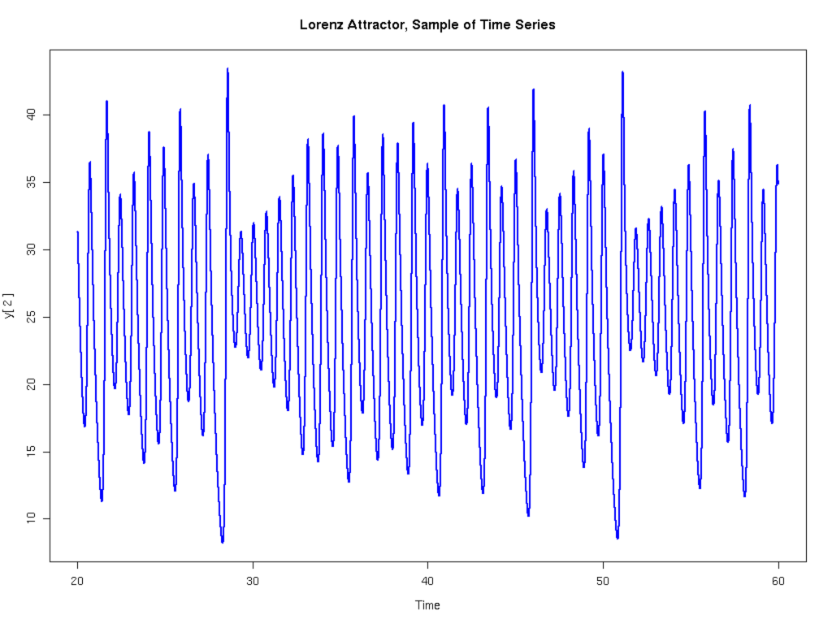
http://lnx-bsp.net/news/2009/01/03/

can the y[2] value of the function at any peak y[2] _{n} be used to predict the value of the function at the next peak peak y[2] _{n+1} ?
if so, we can ignore everything that happened in between the two peaks (leapfrogging)

to find out, have to plot y[2] _{n} on x axis and y[2] _{n+1} on y axis for all the peaks

this maping is called a Lorenz map: the picture of the map:
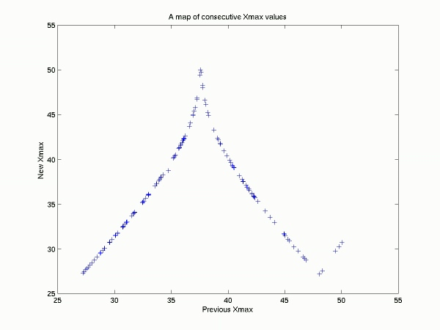
http://andvari.vedur.is/~halldor/HB/Met210old/pred.html

it shows there is a definite relationship between y[2] _{n} and y[2] _{n+1}

this shows the difference between chaos and randomness. This is an astonishing pattern arising out of chaos.

Lorenz attractor: the trajectory grows until reaches a peak on one side of the butterfly, then jumps to the alternate trajectory on the other side of the trajectory:

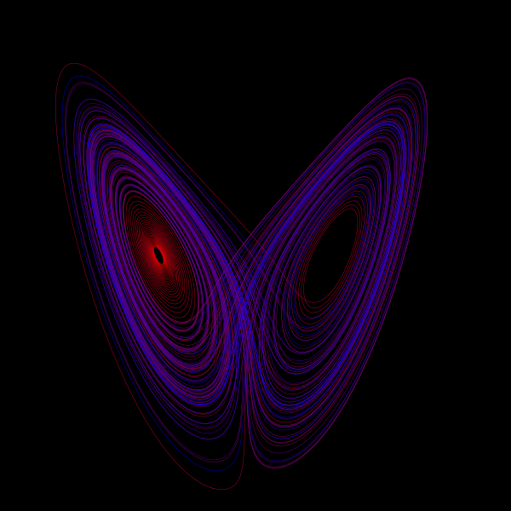

http://courses.washington.edu/phys2278/

order in chaos is always due to non-liner relationships

once again, as with Poincare, Lorenz’s discoveries of the 1970s fell on deaf ears

Lecture 9: How systems turn chaotic
Suddenly many become interested in disorder. They want to know how systems turn chaotic. Different systems may become chaotic in the same way. Three concepts are important:
Iterated maps, bifurcations and the transition to chaos, linearity vs nonlinearity.
Iterated map: feed back calculation; important because provide simples math models from order into chaos.
Two other iterated maps: logistic map: used in ecology
Bifurcation: change in qualitative long term behavior.
Robert May: biologist; urged learning about non-linear systems

Lecture 10: start

Lecture 21: Chaos in Health and Disease
Epileptic seizure indicated by decreasing chaos of brain:

The short term lyapunov exponents (bits/sec) from different positions on the brain decrease and converge: the brain is becoming synchronized.

Leon Lasemidis Chris Sackellares

Note that the brainwaves are lining up, but the chaos at the different nodes is lining up: cannot see it in an EEG

But what about attempts to “synchronize” the left and right hemispheres?

What can chaos theory tell us about arythmias and fibrillation (“chaotic” behavior of heart)

can chaos be good for your heart? Is homeostasis always best?

Ary Goldberger Beth Israel hospital says chaos can be good for your heart

Heart rate variability: rock steady heart rate is associated with congestive heart faliure

Totally Eratic heart beat: fibrillation
Health: variation is fractal thru time
Heart rate variability decreases as we age

Lecture 22: Quantum Chaos

3 conflicts between chaos and Quantum theory

Chaos: deterministic: the present determines the future

Quantum mechanics basic differential eq is Schrodinger’s equation, but it is linear; there is no chaos in linear systems

Heisenberg’s uncertainty principle: destroys concept of state space on which chaos theory rests.

What is a state: the amount of info you need to predict the future of a deterministic system.
Need initial pos & vel, but this is not allowed by HUP.

Distribution of prime numbers:
Riemann added an improvement to the formula for prime numbers which gives the “steps” we see in the distribution of prime numbers. The improvement was adding frequencies

Riemann hypothesis; Riemann’s guess of frequency values needed to model prime number distribution called the music of the primes
Riemann’s waves are the secret to the mystery of the primes.

Quantum systems have discrete energy levels, corresponding to waves vibrating at certain frequencies.
Likewise the secret of the primes are encoded in a discrete set of wave frequencies: the “magic frequencies” Riemann found he needed to give an accurate formula for the prime number distribution. These are given the name the “zeros of the Riemann Zeta function” (magic frequencies).

The frequencies of the Riemann waves look uncannily like the frequencies of a “quantum chaotic system”.

There is some undiscovered chaotic system whose quantum counterpart would hold the secret to the music of the primes. Chaos, atoms, prime numbers all connected. The “atoms” of arithmetic; ie the prime numbers, are connected to the atoms of reality, and the link between them is chaos.

Lecture 24: The Future of Science

Long term order: Chaotic systems motion in state space are not a random mess, but intricate structures called strange attractors.

Intermediate order: strobe light picture of where the system is on a strange attractor. Called iterated map.

Strogatz represents those who hope that chaos of complex systems and emergent properties will yield through reverse engineering answers to the question of how to manipulate or possibly even to create “life”: major schools funding “systems biology” and even “synthetic biology”. Chaos theory being used to design “biological circuits”, building living versions of things electrical engineers have built: toggle switches, oscillators, amplifiers; not built from transistors, but from genes and proteins. Steven Strogatz Chaos DVD teaching company

Chaos theory also shedding light on perhaps the greatest mystery of all: consciousness. Neuroscientists are discovering clues. Found that when we recognize a face, or pay attention to something, parts of the brain fire synchronized electrical signals at a specific frequency (40 hz) This synchronized signal is self organized and arises out of chaos. “It’s a self organizing thing when we have consciousness... Its starting to look like all that we feel or perceive may be just a reflection of fleeting processes of synchronization among neurons in our brain”. Steven Strogatz Chaos DVD teaching company

