dot or inner or scalar product of two vectors:
a . b = |a| |b| cos(theta)
If the dot product of nonzero vectors are zero, then the vectors are perpendicular

cross or outer or vector product of two vectors:
a x b = |a| |b| sin(theta)u ; where u is unit vector normal to the plane of ab
this is a vector whose magnitude is the area of the parallelogram formed by a & b

math images from
http://hyperphysics.phy-astr.gsu.edu/hbase/vecal.html

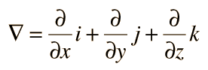

del operator

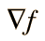

gradient of f

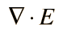

Div of E

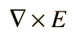

Curl of E

vector potential is a vector field whose curl is a given vector field.

Formally, given a vector field v, a vector potential is a vector field E such that

V =

This is analogous to a scalar potential, which is a scalar field whose negative gradient is a given vector field

Given a vector field F, its scalar potential f is a scalar field whose negative gradient is F

F = -

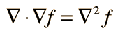
Laplace operator on f

Laplace operator on f = 0 is called Laplace’s equation

In physics and mathematics, in the area of vector calculus, Helmholtz's theorem, also known as the fundamental theorem of vector calculus, states that any sufficiently smooth, rapidly decaying vector field in three dimensions can be resolved into the sum of an irrotational (curl-free) vector field and a solenoidal (divergence-free) vector field; this is known as the Helmholtz decomposition. It is named for Hermann von Helmholtz.
This implies that any such vector field F can be considered to be generated by a pair of potentials: a scalar potential φ and a vector potential A. (???)
http://en.wikipedia.org/wiki/Helmholtz_decomposition

